Dustin McDaniel

355 Game Design – Tutorial Mission 1

YouTube path: <https://www.youtube.com/watch?v=VEtQbhUgS5s>

Pathway: Unity Essentials (2 weeks)

**Mission:** Foundations: Get started with Unity (4 hr 25 min) ✔

* Project: Start Creating (2hr 55 min)
  + Welcome to Unity Essentials (0min) ✔
  + Get the setup wizard (30 min) ✔
  + Unity Plans: What's right for me? (25 min) ✔
  + Install Unity and the Hub (45 min) ✔
  + Explore the Unity Editor (45 min) ✔
  + What’s Next – explore microgame (30 min) ✔
    - Open New Microgame (daKarts) ✔
    - Get Started✔
    - Editor Basics✔
    - Change Colors✔
    - Add a Jump✔
    - Microgame Mods ✔
      * Karting Mod: Crash Course Game Mode (10 min) ✔
      * Karting Mod: Lap Course Game Mode (10 min) ✔
      * Karting Mod: Smart Karts Training Guide (30 min) ✔
    - Build and publish✔
* Project: Start Learning (35 min)
  + Prepare for the journey (20 min) ✔
  + How to learn Unity (15 min) ✔
* Project: Start Organizing (55 min)
  + Introduction to the Unity Hub (15 min) ✔
  + Choose the right Unity version (15 min) ✔
* Quiz – score 5/5 ✔

**Mission:** Explore Unity (10 hr 25 min) ✔

* Project: Real-time creation (1 hr 5 min) ✔
  + What is real-time? (15 min) ✔
  + What is Unity? (10 min) ✔
  + What can Unity do? (30 min) ✔
  + Who are real-time creators? (10 min) ✔
* Project: Essentials of real-time 3D (3 hr 30 min) ✔
  + Work with GameObjects in a 3D Scene (1 hr) ✔
  + Create a structure with primitives (45 min) ✔
  + Add components to 3D GameObjects (25 min) ✔
  + Create effects for 3D GameObjects (30 min) ✔
  + Get 3D Assets (20 min) ✔
  + Challenge: The floor is lava! (10 min) ✔
  + Publish your project (20 min) ✔

<https://play.unity.com/mg/other/murbles-lava>

* Project: Essentials of programming in Unity (1 hr) ✔
  + Get started with scripts (30 min) ✔
  + Code in the default script (30 min) ✔
  + Change a GameObject with script (0 min) ✔
* Project: Essentials of real-time audio (1 hr 20 min) ✔
  + Add background music (15 min) ✔
  + Create real-time 3D audio effects (20 min) ✔
  + Get audio assets (15 min) ✔
  + Challenge: Moving sound (30 min) ✔
    - Use scripting to make a GameObject move. ✔
    - Add an Audio Source Component to a GameObject. ✔
    - Add an Audio Clip to an Audio Source Component. ✔
    - Create a Doppler effect using 3D sound. ✔
    - <https://play.unity.com/mg/other/urp-template-audio-game>
* Project: Essentials of real-time 2D (3 hr 5 min) ✔
  + Work with GameObjects in a 2D Scene (1 hr) ✔
  + Add components to 2D GameObjects (1 hr) ✔
  + Get 2D assets (1 hr) ✔
  + Challenge: Sprite pachinko (5 min) ✔

<https://play.unity.com/mg/other/2d-pachinco-5>

* Project: The real-time industry (25 min) ✔
  + The real-time production cycle (10 min) ✔
  + Roles and careers for real-time creators (15 min) ✔
* Mission summary: Explore Unity Quiz (20 min) ✔
* **Mission:** Learn Unity (1 hr) ✔
  + How our established creators learned Unity (20 min) ✔
  + Develop your learning plan (20 min) ✔
  + Unity's creator community (10 min) ✔
  + Explore game jams (5 min) ✔
  + On to your creative journey (5 min) ✔
* Learn Unity Quiz (5 min) ✔

Blue text indicates extras that were completed but not counted in total (40 min)

**Total Mission Time Completed: 15 hours 50 Minutes**

**Total Mission Time Remaining: 0 hours 0 Minutes**

**Percent Completion: 100%**

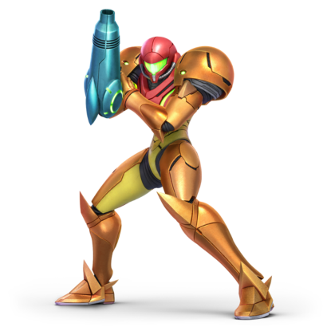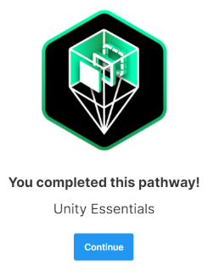

* **U**